LWR036 - Apna Pani

ANDROID - MOBILE APPLICATION

& WEB-PORTAL

USER MANUAL

WELCOME to the LWR036-Apna Pani Mobile App User Guide!

CONTENTS:

ANDROID APPLICATION GUIDE
INSTALLATION - PAGE 4

Account Creation – PAGE 5
LAUNCHING THE APP- PAGE 6
-REQUESTING PERMISSION – PAGE 6
Main Screen-PAGE 7
Register A New Well UI – PAGE 8
Register A New Well UI – PAGE 9
Report A Well UI – PAGE 10
Check A Wells Reading UI – PAGE 11
APNA FARM UI – PAGE 12
Offline Version UI – PAGE 13
Main Menu (Download / Upload) – PAGE 14

WEB-PORTAL GUIDE

CHECK MY WELL – PAGE 16

CHECK MY WELL – PAGE 17

CHECK MY WELL – PAGE 18
APNA FARM – PAGE 19
CWR-GRAPH – PAGE 20
CROP PROFITABILITY GRAPH – PAGE 21
EXPORT RESULT AS PDF – PAGE 22

IMPORT WELL RECORD – PAGE 23

LWR036 - Apna Pani

Module 1: Android Application

Installation

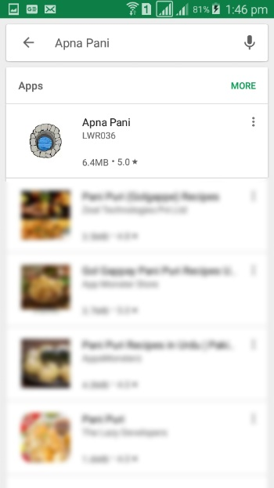

To find the App manually,
navigate to the Google Play Store
and search “Apna Pani” OR https://play.google.com/store/apps/details?id=com.lwr.wells.mrkhan&hl=en_US

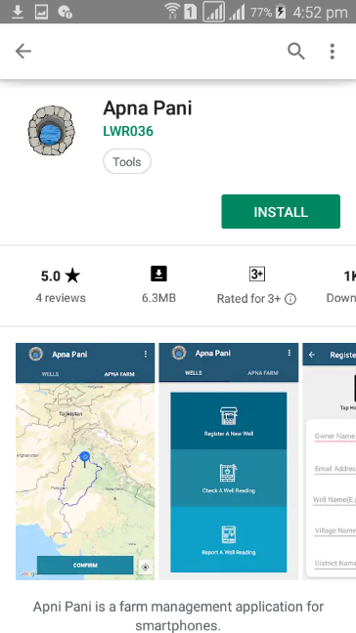

Select INSTALL to begin the

download.
Account Creation
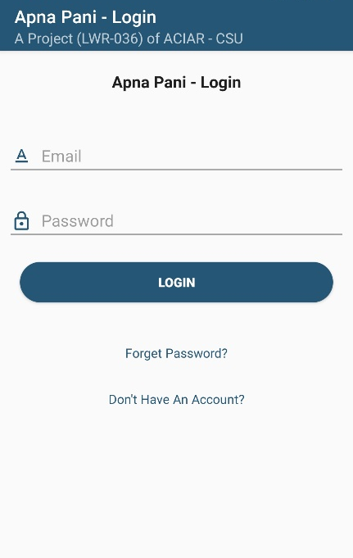
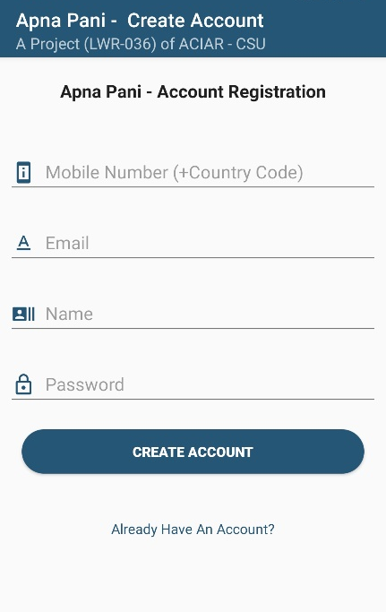
Go to Menu Tap on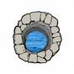Apna Pani Icon to open the Application.

User will be asked to verify Phone number and after verification user will automatically redirect to the Apna Pani – Create Account screen, fill out the fields for account creation, if you already have an Account Just Click on the button Already have an Account and Login with the Credentials.; Please note that User must have the active internet Connection.

Launch Application & Requesting Permission

After Account Creation user will be asked to turn on the Location Services.

Requesting Permission-

The Window will ask user to allow location services.
Deny- Permission not granted: user won’t be able to use application properly
Allow- Permission not granted: user won’t be able to use application properly

(In order to use the application permission should be granted).

Main Screen

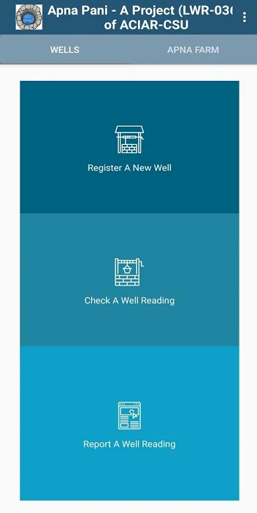

Apna Pani-
Main Screen of the app with two Tabs
WELLS (Default Tab).

APNA FARM.

Well-
This Section has two windows:
Register A New Well – for registering new well.
Check A Well Reading – for Checking well’s reading.
Report A Well Reading – for reporting on daily basis.

Menu Section – The three vertical dots are the menu and provides Downloading and Sharing Capabilities

APNA FARM – The MAP Section of the Application

user will be able to navigate through map to locate own farm and no different parameters of this farm.

Register A New Well UI
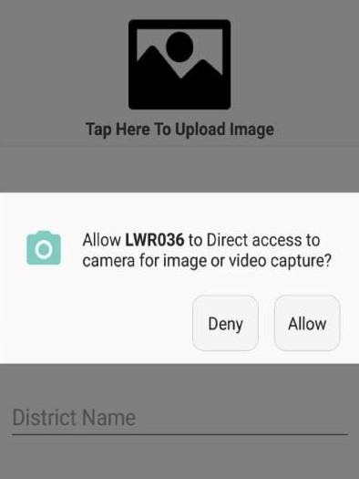

Requesting Permission–

The window will ask user to allow application to use camera.

Deny- Permission not granted: user won’t be able to upload images. Allow- Permission granted:
user will be able to upload images
(In order to use the application permission should be granted

Register A New Well UI

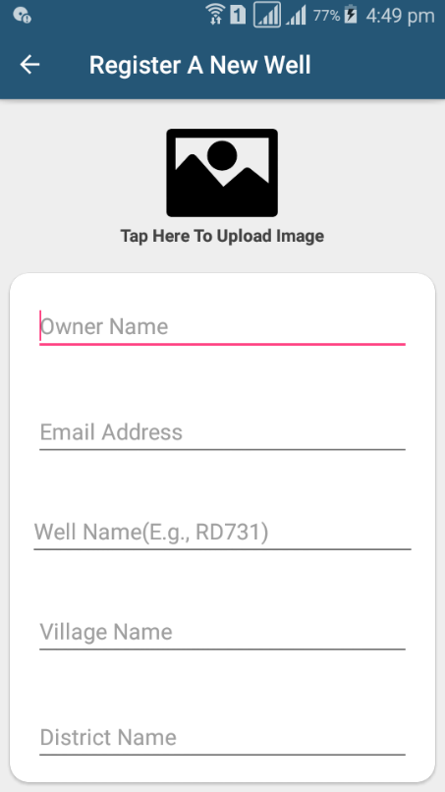

Details–
It is necessary for all users to fill out the Fields.

Post code- This field is optional.
Well Name- This field is optional.

.

.

Image Uploader–
User Will be able to add image of the wells.

Report A Well Reading UI

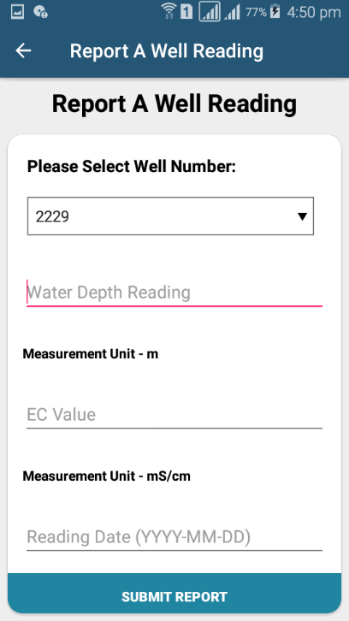

User will be able to select well,
no from the list in case of multiple

wells more than one well no will be present

Reading Values –User will be able to add one Both of them.

Submit Button–
This will Insert all of the record.

Measurement Unit – m for Depth to Water
Measurement Unit – mS/cm for EC

User Will be able to update record on the daily basis of the well by just selecting Well No. from

the drop down and click on the Submit Report. Please Note That: Well No. will only be

generated after the successful Well Insertion. User can enter date or leave it empty.

Check A Well Reading UI

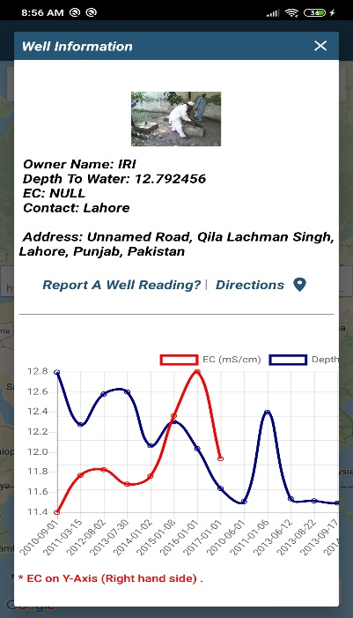
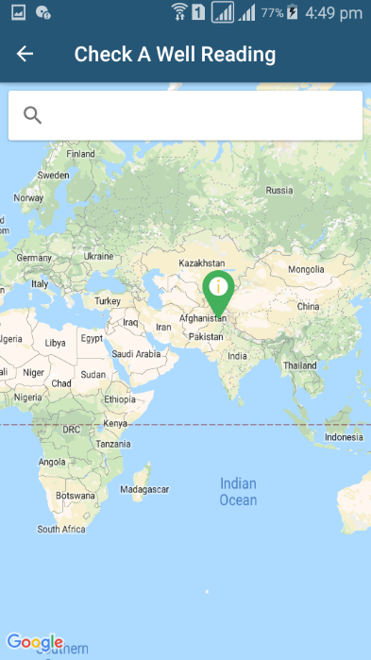
Markers-
This Screen have all the information related
to the wells (Where They Are? What Are the Readings?).
To View Information just to the marker.

Search Bar-
User will be able to search registered well
By entering Owner Name, Well Name and
Location.

Tap on Markers-
By Tapping on the marker, the new screen will
Appear on the Screen and will display
Well Owner Ship, Readings, and Reading Graph
(As shown in the right screen).
User will be able get directions to the well and will be
Able to update readings of that well
(Same as Report A Well Reading UI)

APNA FARM UI

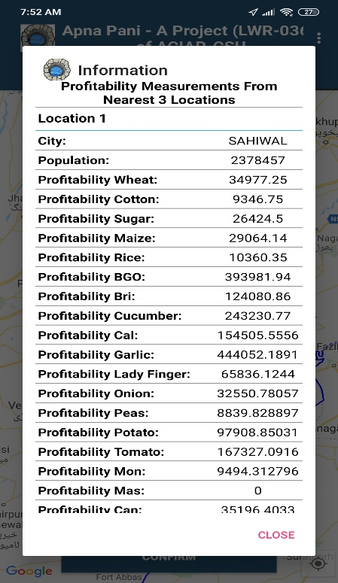
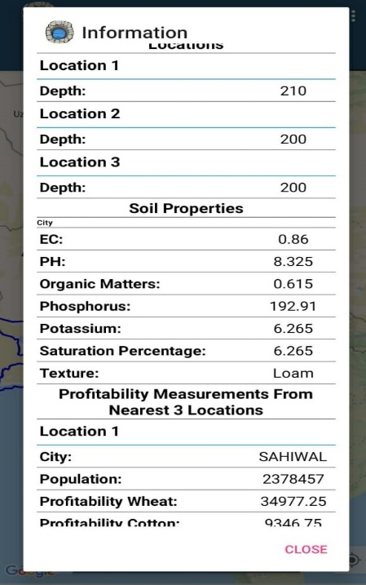
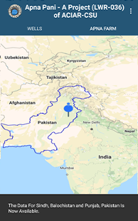
Location Button-
Upon Tap, it will focus user’s current location.
Confirm Button-
This button will display the information related to the land which include: Weather Information, Depth Water, Depth,
Soil Attributes and Profitability
for specific location and
also shows result of next nearest locations.
(As Shown in the Left / Right Screen).

Pointer-
Pointer will move on the screen. (Now bound to move
In Punjab, Pakistan Only: As Shown in Message). Blue Region-The blue bound region is Punjab, PK.

Offline Version UI

Save And Send Later-
When There is no Internet
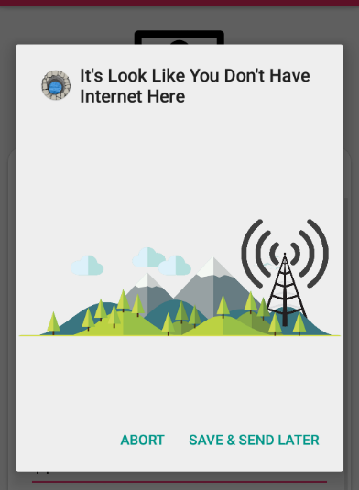
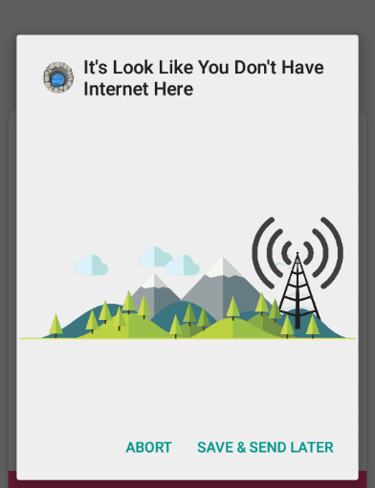
The Following Screen will appear to ask
if you want to add data later.
As soon as internet is available or Abort the Operation.

Main Menu (Downloading / Upload)

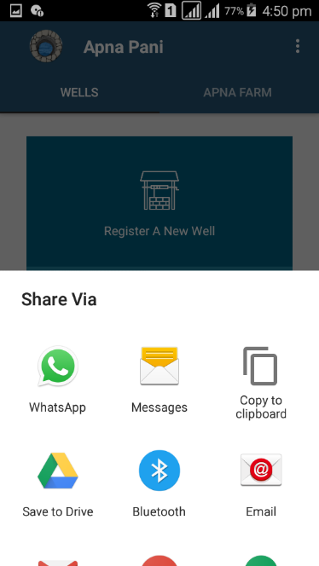
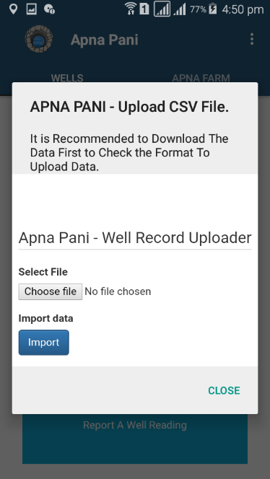
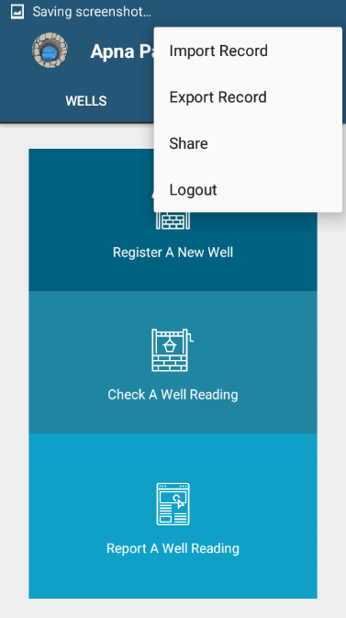
Main Menu -
Main Menu has four Options.
Export Data: To download CSV.
Import Data: To upload CSV (As Shown).
Share: To Share App with others.
Logout: To Sign out from the App.

(Please upload valid CSV with or without Headers.)

Module 2: Web Interface (Apna Farm)

Check Your Well - Web Interface

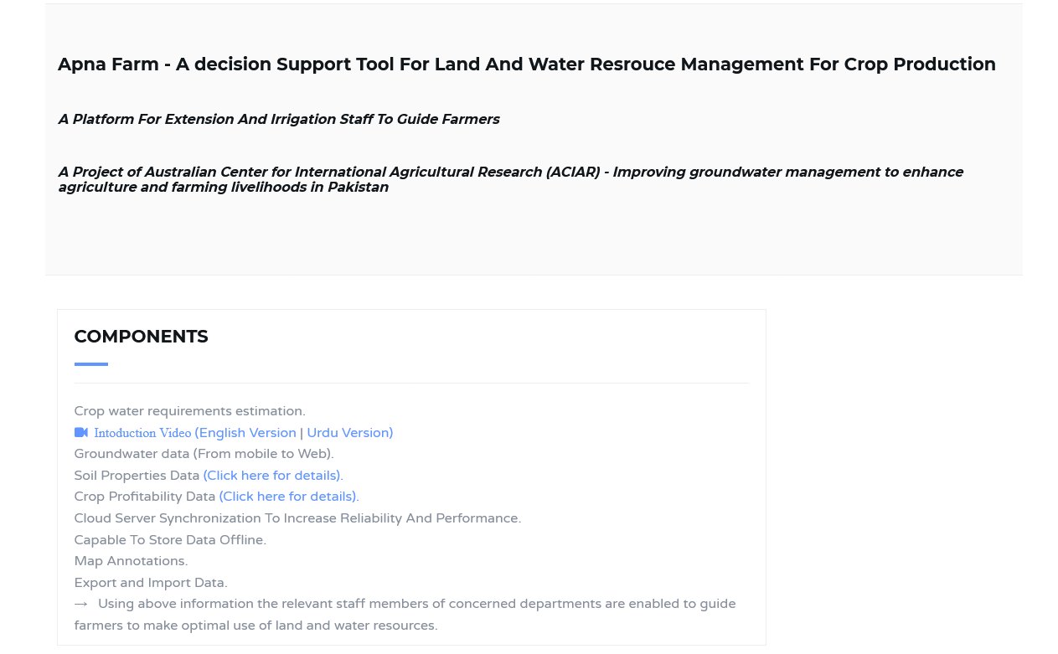

To Check Please Visit: https://www.mriaz-khan.com/aciar/dss

Check Your Well

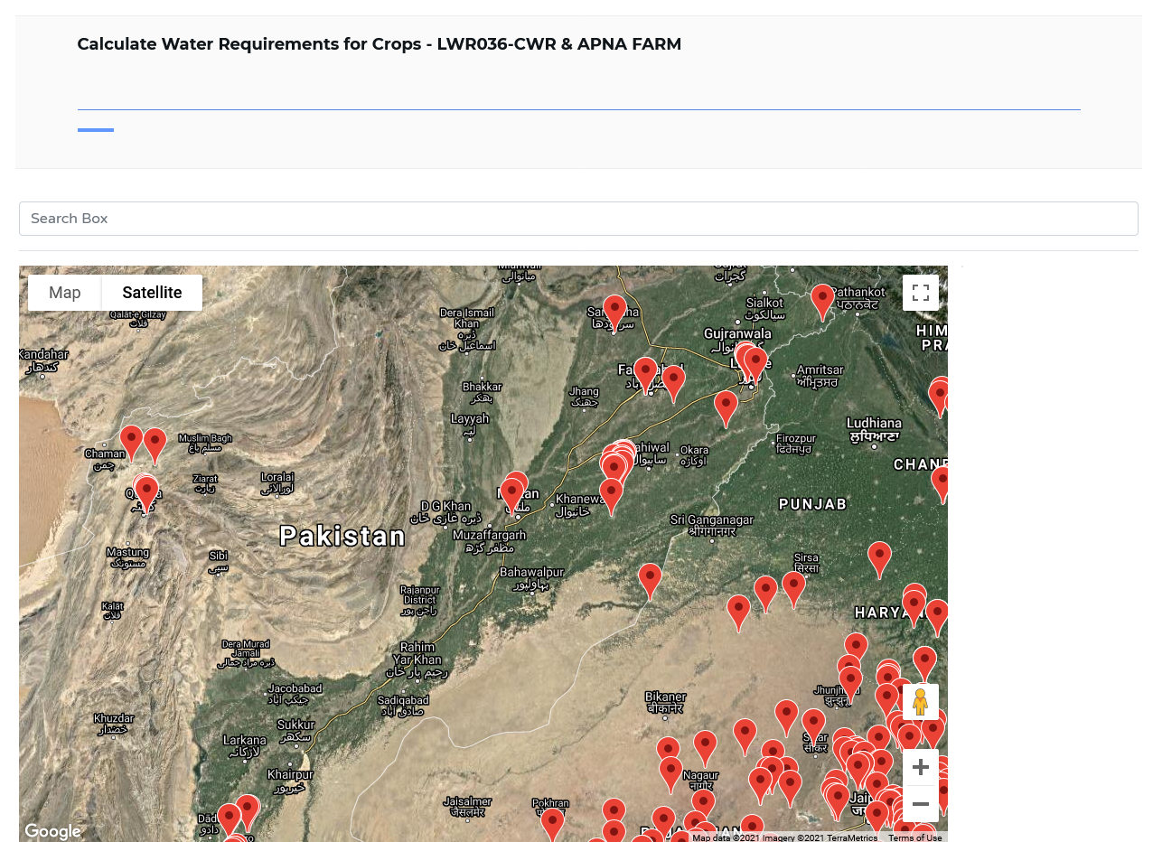

Search Box to search location / Farm.

Markers shows registered wells.

Just Take the Mouse to the marker

and user will be able to see the
information.

Check Your Well
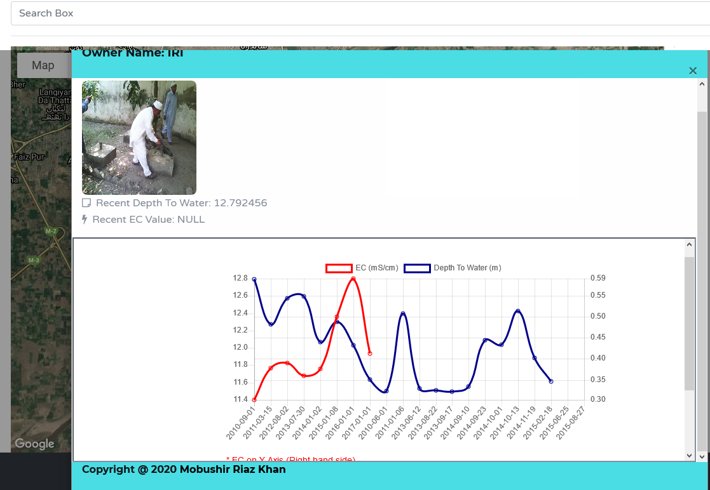
User will be able to check Reading,
Reading Graphs and current weather by clicking on the icon on the map

APNA FARM
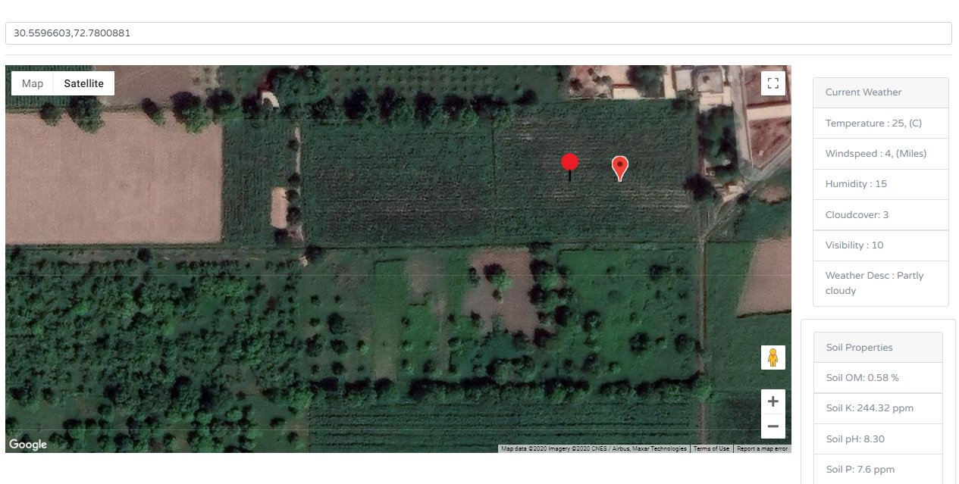

Geo locate farm by typing Lat/Lng in the search bar or simply search location by name and the Weather information, Soil attributes, Crop profitability graphs, Crop water requirement will be visible to the user.

CWR - GRAPH
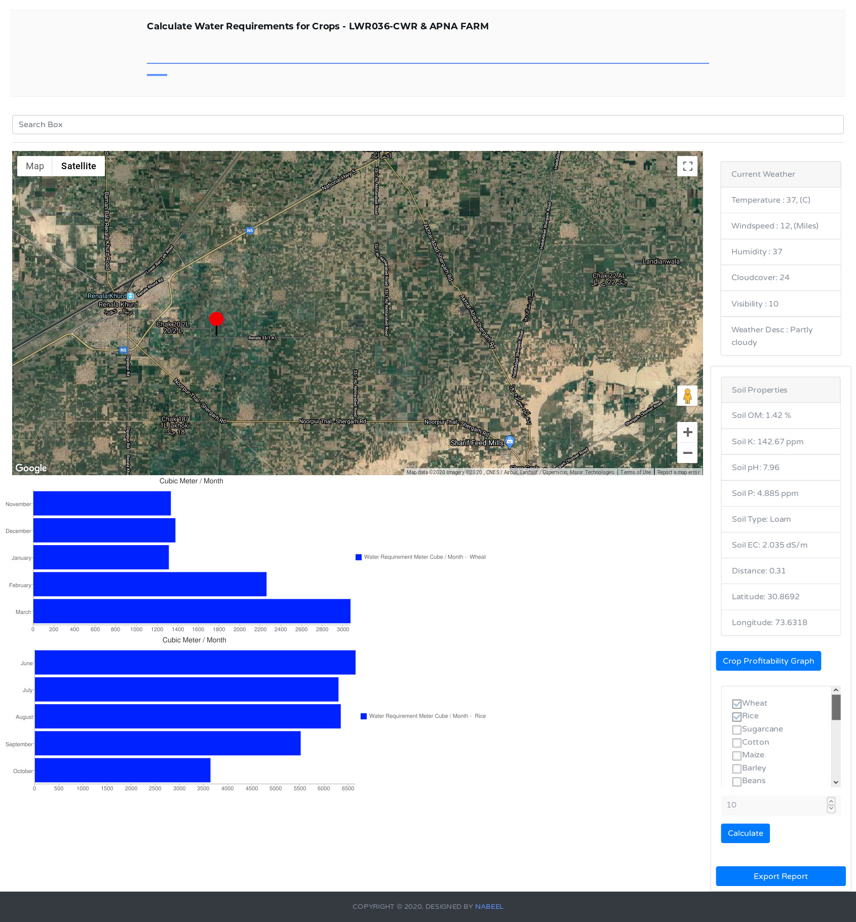

Soil Attributes

Crop Profitability graphs.

Export all searched result as (PDF PAGE 19)
Crop Water Requirements Graphs.
Input crops and area in Acres to calculate CWR graphs.
Crop Profitability Graph

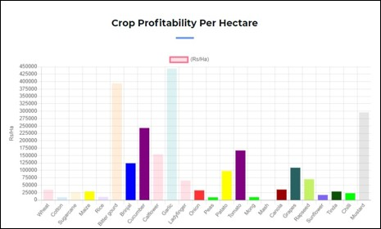

CROP PROFITABILITY GRAPH OF FARM.
EXPORT RESULT AS PDF

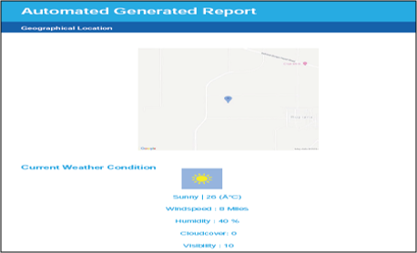

Import Wells Record

Restricted Access: Only for the Admin - http://mriaz-khan.com/LWR036-CWR/lwr/login.php

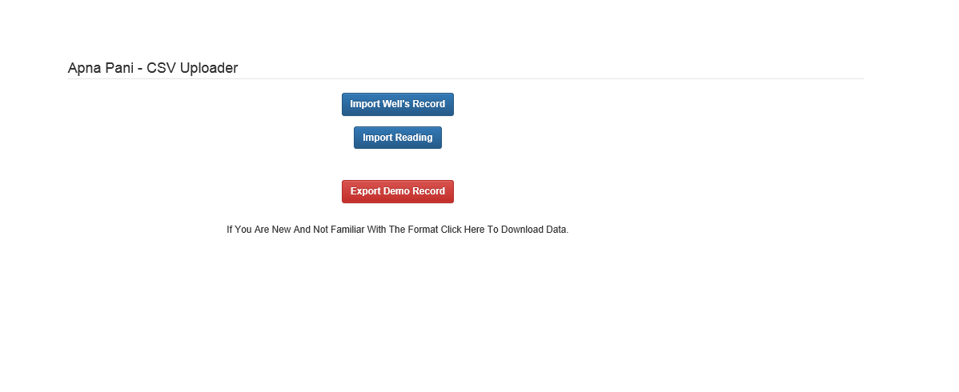

The Interface has three Options: Import Well’s Record, Import Reading
And if you are new with the format there is an option for you to download demo format.

